PROJECT
STUDENT MANAGEMENT
SYSTEM

[PROJECT REPORT FILE]

NAME – ABHINAV RAJ
REG. NO.- 25MEI10070

DEPT.- INT. MTECH CYBER

INTRODUCTION:
This project is a simple CSV based student management system used to store and manage students data efficiently

PROBLEM STATEMENT:
Manual handling of student records leads to an error, duplication, and inefficiency. A simple automated system is required.

FUNCTIONAL REQUIREMENTS:
- Add students
- View students
- Search student
- Update student
- Delete student

NON FUNCTIONAL REQUIREMENTS:
- Performance : Fast file operations
- Usability : Easy to use by any user
- Reliability : accurate data storage
- Performance : fast file operations

SYSTEM ARCHITECTURE:
Command line interface (CLI) interacting with CSV file storage.

DESIGN DIAGRAMS:
USE CASE DIAGRAM
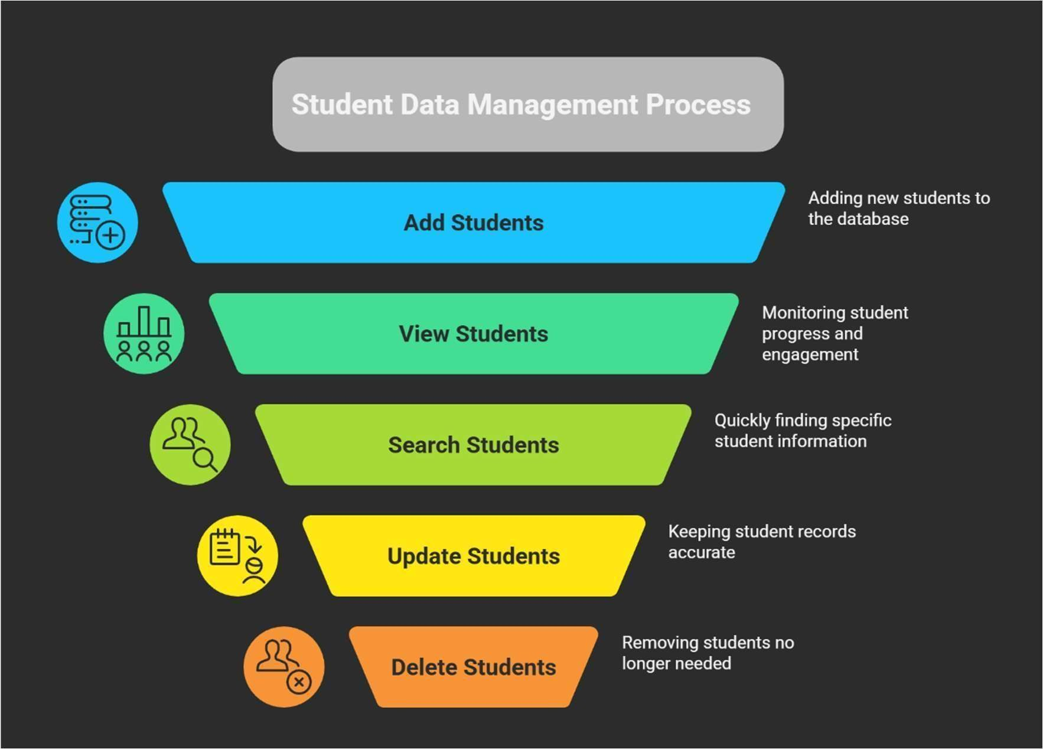

WORKFLOW DIAGRAM
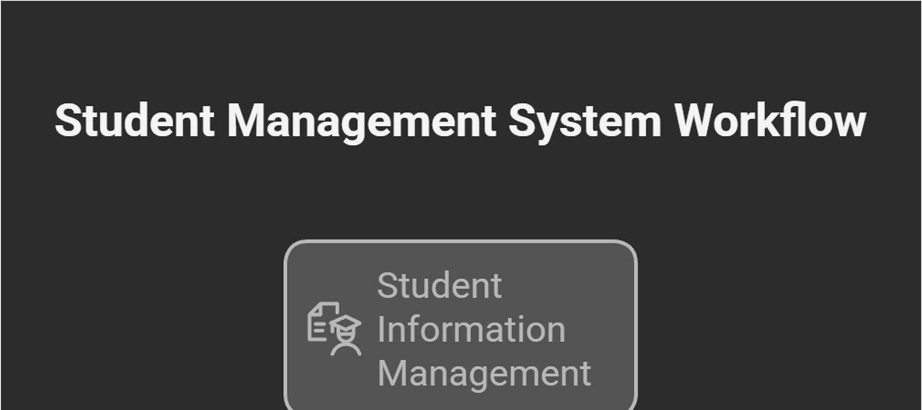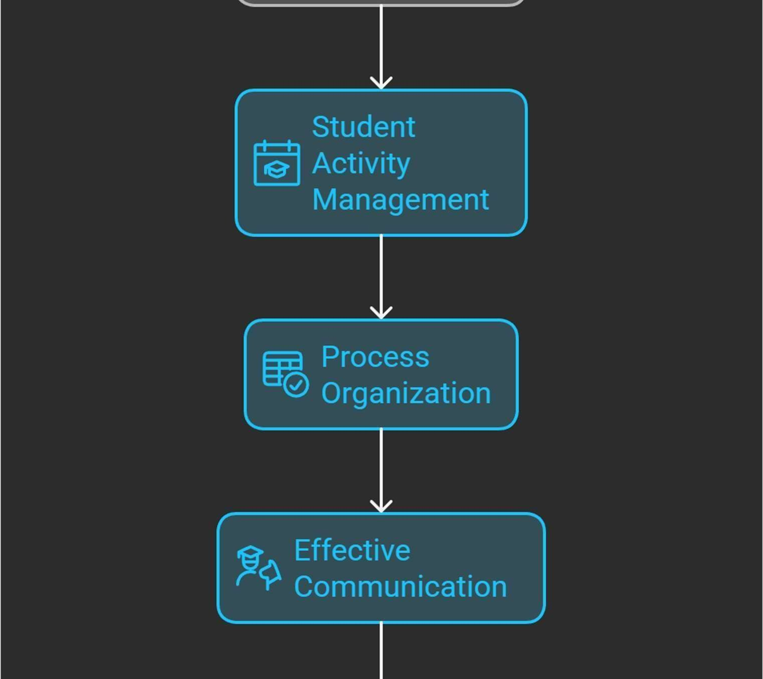
SEQUENCE DIAGRAM
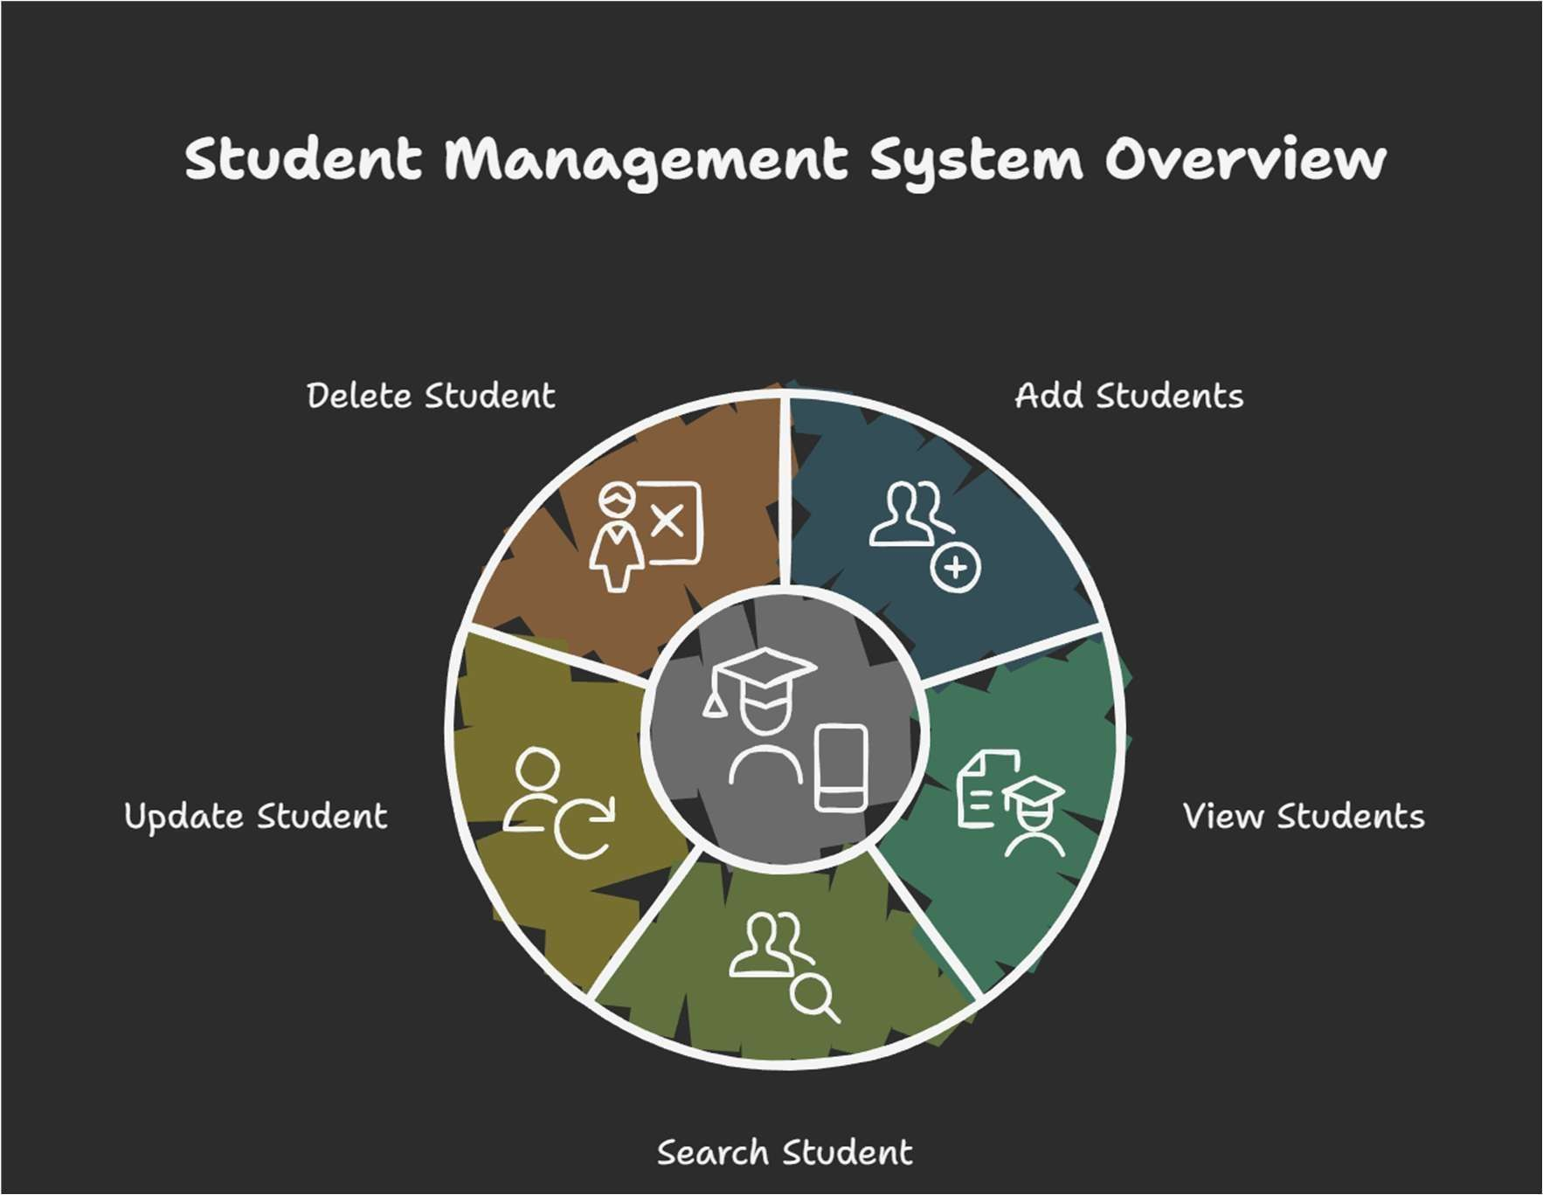

ER DIAGRAM
Roll no.(01)
|
| 1 to many
|
INFORMATION

Design Decisions & Rationale:
CSV chosen for simplicity and beginner-friendly implementation.

Implementation Details:
Implemented using Python and the CSV module with modular functions.

SCREENSHOTS / RESULTS
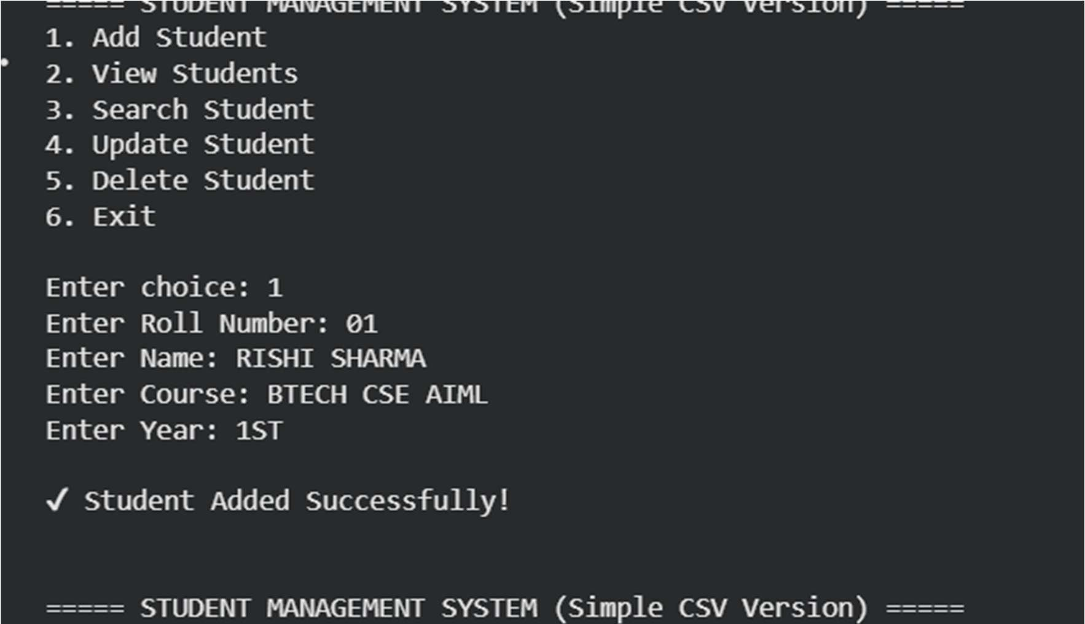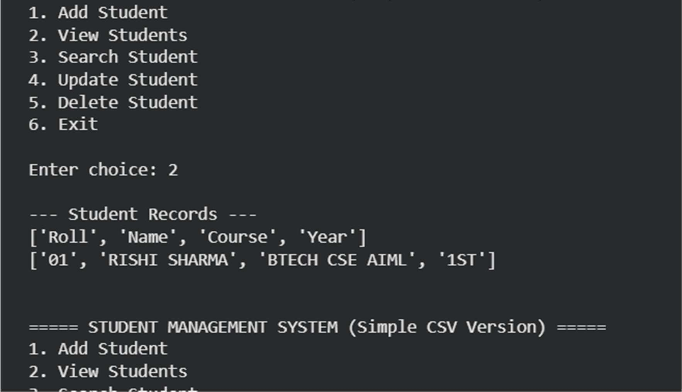
Testing Approach:
Manual testing performed using multiple input scenarios.

Challenges Faced:
Data validation, handling file rewriting, ensuring consistency.

Learnings & Key Takeaways:
Understanding file operations, modular design, and handling user inputs.

Future Enhancements:
GUI, database integration, login authentication, cloud

References:
Python Documentation, Online Tutorials, Class Notes.

